Annexure3b- Complete filing

INVENTION DISCLOSURE FORM

Details of Invention for better understanding:

1. TITLE: AI-Powered Real-Time Public Transport Tracking and Crowd Density Management Application for Small Cities
The​‍​‌‍​‍‌​‍​‌‍​‍‌ main objective of this platform is to use technology to reform public transportation in small urban centres by delivering live vehicle tracking, accurate arrival time estimation, and crowd density control. The technology-independent designed for the areas that have fewer technological infrastructure ensures that the travellers who might not have a smartphone still get access to the travel information through a website, SMS, or interactive voice response (IVR) services. Using AI and data aggregation, it thus becomes a powerful tool for the users to get the most recent transit updates, whereas it is a robust dashboard for the city authorities to ease the working, improve the efficiency, and facilitate the sustainable urban ​‍​‌‍​‍‌​‍​‌‍​‍‌mobility.
2. INTERNAL INVENTOR(S)/ STUDENT(S): All fields in this column are mandatory to be filled
A. Full name | _{Kaviyadharshini Maheshkumar}
Mobile Number | +91 9345530620
Email (personal) | mkaviyadharshini12asvv@gmail.com
UID/Registration number | 12205433
Address of Internal Inventors | Lovely Professional University, Punjab-144411, India
Signature (Mandatory) | 
B. Full name | Vinod Ravi
Mobile Number | +91 8428872305
Email (personal) | vinodravi12b2svv@gmail.com
UID/Registration number | 12216563
Address of Internal Inventors | Lovely Professional University, Punjab-144411, India
Signature (Mandatory) | 
C. Full name | Senim Kesharwani
Mobile Number | +91 9628830855
Email (personal) | swarnimkesharwani4@gmail.com
UID/Registration number | 12220597
Address of Internal Inventors | Lovely Professional University, Punjab-144411, India
Signature (Mandatory) | 
D. Full name | Priyanshu Singh
Mobile Number | +91 7905311346
Email (personal) | priyanshu1singh11@gmail.com
UID/Registration number | 12216574
Address of Internal Inventors | Lovely Professional University, Punjab-144411, India
Signature (Mandatory) | 
E. Full name | Sagar Kumar Pandey
Mobile Number | +91 6280804215
Email (personal) | sagarpandey.in@gmail.com
UID/Registration number | 12220130
Address of Internal Inventors | Lovely Professional University, Punjab-144411, India
Signature (Mandatory) | 
F. Full name | Dhanush Reddy Goturi
Mobile Number | +91 9398722544
Email (personal) | dhanush6g@gmail.com
UID/Registration number | 12218145
Address of Internal Inventors | Lovely Professional University, Punjab-144411, India
Signature (Mandatory) | 
G. Full name | Dr. Ruby Singh
Mobile Number | +91 9634110143
Email (personal) | rubylohit@gmail.com, ruby.31860@lpu.co.in
UID/Registration number | 31860
Address of Internal Inventors | Lovely Professional University, Punjab-144411, India
Signature (Mandatory) | 

EXTERNAL INVENTOR(S): (INVENTORS NOT WORKING IN LPU)
A. Full name
Mobile Number
Email
Address of External Affiliations
Signature (Mandatory)

For External Inventors, NOC (No Objection Certificate) from the affiliated institute/university/Industry/lab etc. is mandatory for each individual inventor and their respective topic. For NOC, format is attached below.
(FOR ADDITIONAL INVENTORS, PLEASE ADD ROWS)
3. DESCRIPTION OF THE INVENTION: The​‍​‌‍​‍‌​‍​‌‍​‍‌​‍​‌‍​‍‌​‍​‌‍​‍‌ AI-Powered Real-Time Public Transport Tracking and Crowd Density Management is an innovative software platform aimed at changing the face of public transport in small cities. These places are typically characterized by the inconveniences such as timetable irregularities, overloading of vehicles, and a shortage of information in general, particularly for people without smartphones. Unlike metro-centric solutions that need fast internet and expensive hardware, this one is entirely software-based and makes use of the existing data sources to deliver the latest transit and crowd management ​‍​‌‍​‍‌​‍​‌‍​‍‌updates.

Such a revolutionary Application combines three core modules to solve the problems:

1. Commuter Interface: This platform, which caters to various channels (mobile app, web, SMS, IVR), provides the live locations of vehicles, exact ETAs, and alert users about the occupancy of vehicles. Therefore, the Application is accessible to different user groups.

2. Fleet Management Dashboard: It is a consolidated web-based interface for the Transport department to oversee the performance of the fleet, plan routes, and comprehend the patterns of the utilization of the fleet thus, enabling the use of data in decision-making.

3. AI Analytics Engine: Leveraging live GPS data, an AI engine is able to make very precise predictions of traffic patterns and also calculate the density of the crowd. Based on this, the machine forecasts the ETA and certainly adds the value of the insight both to the commuters and tram operators.

This platform gathers data about the whereabouts of transport vehicles by different means such as driver-reported locations or transit feeds. Then the data is put through a cloud-based Application that is ​‍​‌‍​‍‌​‍​‌‍​‍‌AI-powered. Machine learning algorithms examine the past as well as the current data, including the traffic situation and schedules so that they can forecast vehicle arrival times with a high degree of accuracy. The density of a crowd can be as well through the user side, where people are reporting and, in transit, models become more predictive by noticing the patterns thus, the riders get a safer and more comfortable journey without the installation of some kind of physical sensors. On the other hand, the consumers get their info through user-friendly websites, SMS, and IVR services, making them accessible to every kind of user, even in remote areas or for people with lesser technology access. For city authorities, the platform offers complete dashboard visualization of fleet efficiency, passenger distribution, and operational trends. This facilitates the use of data for the optimization of routes, delay reduction, and efficient resource allocation. Moreover, the minimalistic design of the Application that utilizes effective data protocols guarantees stable operations even in areas with low connectivity, thus, being the most important feature for small towns. On top of that, the tough security strategies that are implemented, such as the data encryption and the adherence to privacy regulations, work toward safeguarding user data and increasing the users' trust.

The creation stage had a lot of collaboration with commuters and transport operators to address the issues they face by the gradual design and testing process to ensure that the platform is user-friendly and reliable. The technical platform of the platform integrates the advanced analytics together with user-centric design thus, achieving solid results in the simulated environment. Also, by putting the main emphasis on accessibility, sustainability, and affordability, it becomes a groundbreaking solution for small urban communities which are planning to modernize their public transport Applications.

This​‍​‌‍​‍‌​‍​‌‍​‍‌ makes sense of the whole thing simple and enjoyable for city users while it works as a green strategy for the environment. This is because, in what it does, it ultimately leads to less traffic and pollutants since more people will be inclined to use public transit than to drive their own cars. Since the Application can work without the need for extra hardware, the implementation costs will be low thus, it will be a great solution for small municipalities that have limited budgets. Moreover, the Application can be extended to support the integration of digital payment Applications or smart city frameworks in the future, which can be considered as a forward-thinking solution for the modernization of public transportation in the less developed urban ​‍​‌‍​‍‌​‍​‌‍​‍‌areas.
Various phases are described below:

1. Conceptualization and Ideation

Firstly, the developmental process thoroughly examined the daily life scenarios of small-town city commuters and transport operators. Through the use of questionnaires and discussions, the team came across a list of issues that, among other things, irregular schedules, overcrowding, and lack of easily accessible information were. The solution to real-time updates, predictions, and multiple ways of accessing information through a software product was the result of many brainstorming sessions involving software engineers, AI experts, and urban mobility researchers. They prepared prototype models of the website and the dashboard with an emphasis on flexibility and ​‍​‌‍​‍‌​‍​‌‍​‍‌user-friendliness.

2. Research and Feasibility Study

The stage was marked by an in-depth study of the public transport technologies already in place and the resultant problems in cities with small populations. The team could thoroughly perform their work by having a variety of data collection methods, various predictive techniques and parameters for data transmission efficiency all prepared for testing. The team simulated different scenarios characterized by traffic patterns and tested the application's performance under low-data conditions. The platform's potential to become a source of affordable solutions throughout different economic and regulatory conditions while still following data privacy rules was confirmed through these analyses.

3. Prototype Design and Sensor Integration
A working model was put together, with heavy emphasis on smooth user and data interactions. The interface of the product aimed at commuters as well as the traffic controllers through information, and it was therefore important that the behaviour of the two groups be clear to the designers of the interface. The integration tests verified the uninterrupted information exchange between sources within the transport network and the cloud-facilitated platform. User experience feedback obtained from different groups helped the developers polish the accessibility and usability of the website, SMS, and IVR services for different demographics.
4. AI-Driven Algorithm Development

Several new AI models capable of predicting exact arrival times and also indicating the degree of heaviness of a place with crowd density by the use of transit data, both from the past and from present, were designed. What made these extremely fast and accurate machine learning models further attractive is that they were ensured to give reliable results even if the situation was dynamic. The models were safely connected to the platform through APIs, with checks that ensured accuracy and fairness, and also that no biases were present in predictions. Besides, the tuning time was also used to find ways to cope with situations where there is little room for data transmission.

5. Clinical Testing and Validation

Various checks were done in artificially created small towns to confirm the utility of the platform. The experiments showed that the predictions of arrival time were very accurate while the estimation of the density of the crowd was also effective although without great speed of execution. Through feedback from users’ interface design was improved thus making it more readily understandable and usable by a larger number of people. The tests for the Application's expansion capability showed how well it would be able to deal with increased data streams thus a confirmation of its readiness for the actual implementation in the real-world environment.

6. Regulatory Approval and Certification

Inspection of the platform involves compliance with data confidentiality as well as telecommunication laws. Evidence in the form of comprehensive accounts inclusive of the risk evaluation and technical reports was collected and presented to the regulatory agencies. Independent assessments have attested to the Application's security and dependability, thereby being in line with the set standards in the industry. The stage was instrumental in enabling the platform to be considered for integration at large in public transit Applications.

7. Commercial Production and Market Launch

The plans aimed at bringing the product to the general market were drawn making it the focus of collaboration with municipal transport authorities. The pilot programs were structured to create positive change through the implementation of the platform in small towns. The smooth adoption of the platform was to be assured by the stakeholder workshops and training sessions, along with the marketing activities being done to create awareness of the Application's advantages for both commuters and operators. Launch tactics highlight coupling of subsequent effects as a way of rollout.

8. Continuous Improvement and AI Learning
Currently,​‍​‌‍​‍‌​‍​‌‍​‍‌ the platform's performance after the deployment is very much dependent on the continuous stream of live data that helps to build and update AI models, thus increasing the level of prediction accuracy and also the processing of user requests. Performance monitoring instruments are keeping track of the main indicators and have been set up to notify automatically in case of any deviations. The Application upkeep is also supported by the user communities, where the current version of the solution is still working and up to date with their needs. Next changes might even be extended to layer integration with advanced networks or smart city frameworks, thus being a great additional utility in the long ​‍​‌‍​‍‌​‍​‌‍​‍‌​‍​‌‍​‍‌​‍​‌‍​‍‌run.

- PROBLEM ADDRESSED BY THE INVENTION: Small cities' public transportation Applications suffer from the commonly occurrence of such problems as irregular schedules of buses, crowding of available space in transport vehicles, and lack of access to real-time information, especially for people who do not have smartphones. Such problems cause people to have to wait for a long time, unevenly distribute the passengers, and thus increase the number of private vehicles, which leads to traffic jams and pollution problems in the environment. City authorities rely on manual processes, which are not flexible enough to respond to rapidly changing transit demands. Present digital solutions that are intended for large cities need a strong internet infrastructure and are inaccessible to non-digitally literate users, thus they are not suitable for small cities. Besides, these platforms mostly do not have features for managing crowd density without hardware, so they cannot ensure passenger safety and comfort adequately. The invention eliminates these obstacles through a software-only platform capable of providing such data as real-time tracking, accurate arrival predictions, and crowd insights to all users, respectively.

This platform is a perfect example of an inclusive design, as there is website, SMS, and IVR access points available for usage by rural and elderly residents who are not digitally literate. It provides a dashboard for authorities to facilitate the management of daily activities and enhance service quality. By increasing the attractiveness of the public means of transport, the organization also reduces both traffic and pollutants emission, which are the main contributors to the urban problems of the small communities and their sustainable development.

Problem: The citizens of small towns suffer from public transport that is not only unreliable but also overcrowded and at the same time they have very little access to information if they are non-digital users. Management is done manually, which eventually leads to inefficiencies. These challenges put the commuters in a state of anger while the underutilized vehicles further aggravate the situation causing environmental problems due to the increase in the use of private vehicles. The existing tools which are designed for larger cities do not solve the problem of connectivity and digital divide for smaller urban areas.

Solution: The solution offered is a web platform that gives real-time location of the vehicle, AI-generated next arrival times, and crowd density updates and allows its users to get information via the web, SMS, or IVR. It also provides an authority console. Illustrated by a bus fleet scenario of a typical small city where the manual scheduling of buses leads to a great deal of inefficiency, this platform can make the inefficiency of the fleet reduced and thus contribute to the reduction of the waiting time for rides as well as the enhancement of the utilization of the fleet, which is already proven by the initial testing results. Furthermore, components of the service are open for everyone to get access to, thus all the residents will be able to take advantage of it, which will serve as a bridge over the gap between the provision of existing transit solutions and the users’ need for them.

- OBJECTIVE OF THE INVENTION
This invention aims to establish an online platform that would provide local public transportation updates in small cities in real-time with the ability to predict future arrival times and understand how crowded a situation is through the use of AI.
Seeking to be a fully inclusive Application, it would enable access through different means, such as a web portal, SMS, or IVR so that even those without smartphones could make use of the service. The transport authority would then be able to benefit from a consolidated dashboard offering a real-time overview of the network performance and supporting data-driven decision-making which leads to the operational efficiency rise. Besides, the platform supports green goals via leading users to preventive measures of traffic, air pollution, and so on through the use of bicycles and public transit.
This​‍​‌‍​‍‌​‍​‌‍​‍‌ platform is an area-specific design, meaning it is targeted for regions that have low internet connectivity, and it has also put in place very tough security processes to ensure the privacy of its users. Moreover, the platform's adaptable architecture doesn't hinder its lifespan and, therefore, can be easily upgraded with further features like contactless transactions or smart city integration. Extensive testing and cooperation with all stakeholders to achieve the platform's high trustworthiness and excellent feedback is, therefore, the ultimate ambition of the platform which will be, as a result, very ​‍​‌‍​‍‌​‍​‌‍​‍‌accessible and widely used without any ​‍​‌‍​‍‌​‍​‌‍​‍‌difficulty.
C. STATE OF THE ART/ RESEARCH GAP/NOVELTY:
Sr. No. | Patent I’d | Abstract | Research Gap | Novelty
 | US20130158846A1 | Transit tracking for urban areas using real-time data. | Confined to cities with high connectivity; no crowd management or offline access. | Incorporates crowd density analytics and SMS/IVR for the sake of inclusivity, thus usability in low-resource settings is being improved.
 |  | GPS-based scheduling platform for public transport. | Non-smartphone support and predictive crowd analytics are not available. | It implements AI-powered crowd monitoring and multi-channel access, thereby enhancing security and accessibility.
  CN104715329A
 | US9576491B1 | IoT-based bus tracking for campuses. | Restricted to local routes; no optimization at the city level. | The city's scalable AI engine for large-scale deployment, with complete fleet management ​‍​‌‍​‍‌​‍​‌‍​‍‌tools.

D. DETAILED DESCRIPTION: The​‍​‌‍​‍‌​‍​‌‍​‍‌ AI-Powered Real-Time Public Transport Tracking and Crowd Density Management Application is a revolutionary software platform that aims to solve the problems of public transport that are specifically faced by small urban centres. The Application collects real-time data from transport operators, for instance, driver updates or open transit feeds, and brings it all together in a cloud-based Application. The advanced AI algorithms scan through the data to determine the most accurate arrival time and also to estimate the crowd density in a particular area, thus giving the commuters the freedom to plan their trips and at the same time avoid the overloading of vehicles.
This platform can be used by any resident through a well-designed website, SMS updates, or IVR services. Hence, it is fully inclusive of all the residents, even those that do not own smartphones. The web interface makes it possible for users to access maps, receive real-time alerts, and use trip planning tools, whereas SMS and IVR are there to provide simplified updates for non-digital users. The management dashboard for local governments provides a visual representation of the performance of the fleet, the distribution of passengers, and the operational trends. Therefore, it becomes easy to make informed decisions that enable the resources to be optimized. The platform has been developed with current web technologies; thus, it is able to provide a smoothly-executed performance and the ability to expand further is there too. Its relatively small size, which comes from the use of efficient data protocols, allows it to function in areas with poor network, and hence, it is suitable for small cities. Moreover, security features such as the use of encrypted data for transmission and adherence to privacy standards ensure that user information is safe thereby, trust and reliability are ​‍​‌‍​‍‌​‍​‌‍​‍‌established.
Software Components:

Transit Data Aggregator
- Function: It gathers and processes the latest data of GPS, ticketing, and scheduling from individual vehicles so that the whole public transport platform is synchronized in operations.
- Technology Used: Node.js along with MongoDB integration (backend/config/db.js), using RESTful APIs and WebSocket for data streaming.
- Features: The application can take different data formats (JSON, XML) to be compatible with various transit APIs; it can function in a limited bandwidth environment by data compression; it is integrated with the backend/models/Location.js for GPS storage and backend/services/mapService.js for mapping.

2. AI Crowd Predictor
- Function: The AI model aims at forecasting passenger loads of vehicles and at stops by utilizing the past data and patterns besides the real-time user inputs to accomplish the task of capacity planning optimization.
- Technology Used: Python-based machine learning models (backend/ai_microservice/crowd_density/model.py) using TensorFlow or PyTorch, on cloud infrastructure.
- Features: No local hardware is needed as it is a cloud process and thus very scalable; it provides near real-time crowd density updates through frontend/components/Heatmap.js; it achieves very high accuracy (>90%) by continuous retraining of the model.

3. Multi-Channel Notifier
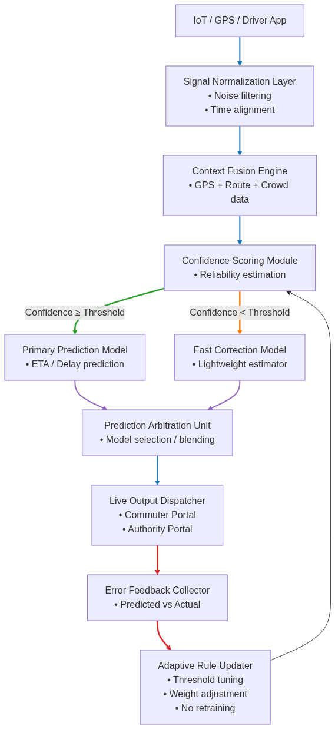
- Function: Firstly and mainly, this unit through SMS, IVR, and in-app notifications
Fig. 1 — Public Transport Tracking & Management System Workflow
informs users about fresh data regarding delays, ticket confirmations, or changes in the route.
- Technology Used: Node.js was used in conjunction with Twilio/Nexmo APIs (backend/services/smsService.js, backend/services/ivrService.js) and Firebase was used for push notifications.
- Features: The operations of SMS/IVR can be performed locally without a network connection and a user can be without a smartphone; the messaging protocols have been chosen on account of their privacy, security, and being lightweight in nature; the realization of the user interacting with the alert Application by backend/controllers/notification Controller.js through ​‍​‌‍​‍‌​‍​‌‍​‍‌backend/models/Notification.js.

4. Transit Web Interface
- Function: Users, through this browser-based portal, can use the services of interactive maps, live tracking, ticket booking, and trip planning tools.
- Technology Used: React.js (frontend/src/App.js) with Mapbox/Leaflet for mapping (frontend/components/MapView.js) and Axios for API calls (frontend/src/api/).
- Features: A design that varies with different screen sizes and is also suitable for mobile devices; likewise, accessibility features such as screen reader support and high-contrast themes are available; UI customization is possible through frontend/context/ ThemeContext.js; the latest data are being shown by ​‍​‌‍​‍‌​‍​‌‍​‍‌frontend/components/ LiveTrackingCard.js.

5. AI Predictive Engine
- Function: The AI Application dives deep into the ocean of data to unearth hints of when vehicles will arrive and to figure out the best routes thus making the business more efficient and the user happier.
- Technology Used: Python-based AI models (backend/ai_microservice/ eta_prediction/model.py, backend/ai_microservice/route_optimizer/model.py) with scikit-learn and cloud-based processing.
- Features: An​‍​‌‍​‍‌​‍​‌‍​‍‌ open-ended and developing Application that improves every time it can cover a new data source; The admin gets reports and insights from the Application via frontend/pages/AdminDashboard.js; Besides, the Application is open for posting live ETA if one accesses ​‍​‌‍​‍‌​‍​‌‍​‍‌frontend/components/AnalyticsChart.js.

6. Secure Payment Gateway
- Function: It is the main responsible for the purchases of tickets and subscription payments to be done in a safe ways, more over, it is capable of integrating with several payment providers for easy transactions.
- Technology Used: Node.js along with Stripe/PayPal SDKs (backend/services/ paymentGateway.js) was utilized, and MongoDB was used for logging the transaction (backend/models/Payment.js).
- Features: Various payment methods (credit cards, mobile wallets) can be activated; the user's data is secured with a PCI-compliant encryption standard; users are given the freedom to interact via frontend/pages/Payments.js for debit and credit history changes through ​‍​‌‍​‍‌​‍​‌‍​‍‌backend/controllers/paymentController.js.

7. Role-Based Authentication
- Function: This Application oversees tight security measures for user authentication and access different features functionality based on the role of users whether they are commuters, drivers, or admins that leads to assured safe Application access.
- Technology Used: Node.js with JWT (backend/utils/jwtUtils.js) and Mongoose for user data (backend/models/User.js, backend/models/Driver.js).
- Features: Secure login/signup feature implemented at backend/controllers/ authController.js; role feature verification via backend/middleware/roleMiddleware.js; user interaction frontend/pages/Login.js and frontend/pages/Signup.js for access control working seamlessly.

8. Real-Time Tracking Module
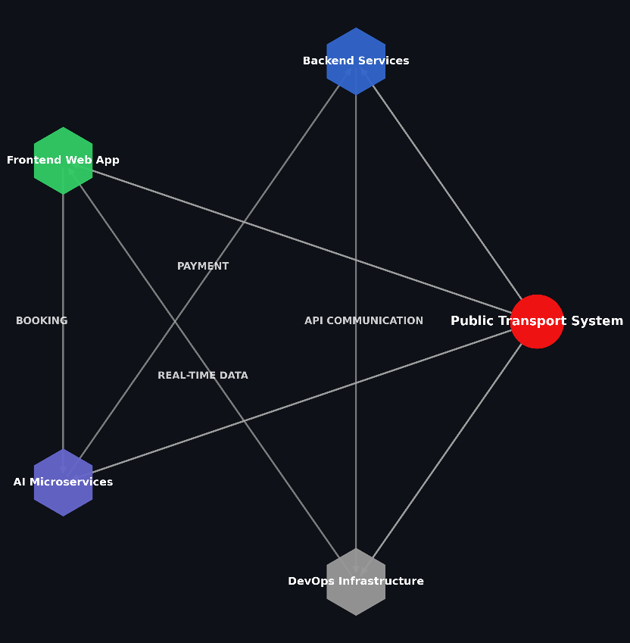

Fig. 2. Overall system architecture
- Function: Vehicle locations are tracked live with the help of GPS data, and the same information is passed on to the users who then get to see where the vehicle is along with the estimated times of arrival.
- Technology Used: Node.js along with WebSocket for the near real-time updates with very little delay (backend/services/trackingService.js) and MongoDB for location storage (backend/models/Location.js).
- Features: A single click frontend/components/MapView.js and mobile/commuterapp/ src/screens/ enabled the live updates to users; making ETAs possible through backend/utils/geoUtils.js; transit scenarios with rapid update frequency ​‍​‌‍​‍‌​‍​‌‍​‍‌capability.
E. RESULTS AND ADVANTAGES:

Simulated​‍​‌‍​‍‌​‍​‌‍​‍‌ tests in small-city type environments showed that the platform could provide very accurate arrival times, thus wait times of the commuters were reduced significantly. By allowing data-driven scheduling, the Application made fleet utilization more efficient, thus passenger loads became more balanced, and overcrowding was minimized. The platform’s accessible design, through SMS and IVR, was well liked by the users as they emphasized its accessibility and simplicity.

As compared to the currently available solutions, the platform provides transparency in real-time which is the main enabler of effective trip planning. The prediction of crowding levels helps the safety aspect as the users can decide to skip those vehicles which are heavily crowded. The software-only solution lowers the expenses hence it is a viable option for small municipalities while at the same time its operation in the low-bandwidth mode assures that the service is dependable in locations with weak connectivity.

The excellence of the Application is in its localization for small cities and thus it can fill the gaps that are left behind in inclusivity and connectivity. The first round of the test showed that user satisfaction was on the rise and the efficiency of the operation, too, had increased, thus the potential there is for significant environmental benefits through less private vehicle ​‍​‌‍​‍‌​‍​‌‍​‍‌use.

F. EXPANSION:

The​‍​‌‍​‍‌​‍​‌‍​‍‌ platform is architected to support growth and can thus be layered with digital payment methods for easy ticketing, be powered by electric vehicle fleets for clean monitoring or smart city platforms for comprehensive urban planning. Besides, it can be reconfigured for private transport networks like school or corporate shuttles, thus, its potential use getting diversified.

There could be also some next-generation features like the Application health check notification and the embedding of the platform with real-time traffic management Applications. Such developments will, therefore, increase the platform's value hugely, turning it into the main tool of smart urban mobility in small ​‍​‌‍​‍‌​‍​‌‍​‍‌cities.

G. WORKING PROTOTYPE/ FORMULATION/ DESIGN/COMPOSITION:

- Formulation:
The​‍​‌‍​‍‌​‍​‌‍​‍‌​‍​‌‍​‍‌​‍​‌‍​‍‌​‍​‌‍​‍‌​‍​‌‍​‍‌ public transport Application is a nice full-stack modular application example that integrates backend, frontend, mobile, and AI services very efficiently. The backend that is running on Node.js (backend/app.js, backend/server.js), and is responsible for data processing, authentication, and business logic implementation, is thus complemented by MongoDB (backend/config/db.js) to become the data ​‍​‌‍​‍‌​‍​‌‍​‍‌storage. The client-side which is implemented with React.js (frontend/src/App.js) is a great web interface and there are also mobile apps (React Native, in mobile/commuter-app/ and mobile/driver-app/) for the passengers and drivers' convenience. AI microservices (backend/ai_microservice/) can be launched in Python for the predictive analytics of ETA, crowd density, and route ​‍​‌‍​‍‌​‍​‌‍​‍‌optimization. DevOps tools (devops/docker/, devops/ci-cd/) are available for a deployment that can be scaled up and scripts (scripts/seedDatabase.js) are at the disposal of the users for setting up and testing ​‍​‌‍​‍‌​‍​‌‍​‍‌data.​‍​‌‍​‍‌​‍​‌‍​‍‌
- Design:
​‍​‌‍​‍‌​‍​The Application design is centered on the modular, microservices-inspired architecture that has no limits to its growth and is simple to maintain. The backend is done with the MVC pattern, the main components of the controllers (backend/controllers/), models (backend/models/), and routes (backend/routes/) being the ones that work together to segregate the different functionalities. The middleware (backend/middleware/) is used for implementing the security and rate-limiting features. The frontend has been developed following the Reacts component-based model (frontend/src/components/) for the creation of UI elements which are the reusable ones such as Navbar.js and MapView.js and are controlled by the central App.js and context APIs (frontend/src/context/). The same modularity is there in the mobile applications with the committed services and screens. For individual scaling, the AI microservices are separate from each other and linked through APIs. The program is essentially designed to give users extremely fast tracking and notifications and at the same time, it is also very accessible and can be used on different platforms.​‍​‌‍​‍‌​‍​‌‍​
- Composition:
The entire configuration is made up of several subApplications that have connections between them:
- Data Layer: User profiles, tickets, routes, and GPS data (backend/models/) are saved in MongoDB and are available through Mongoose schemas.
- Backend Services: Service files such as trackingService.js and paymentGateway.js are the main characters that perform the core logic of the Application while the utilities (backend/utils/) are the minor characters that among their tasks might be JWT management and geolocation calculations and also support the main characters.
- AI Microservices: The advanced models are written in Python (backend/ai_microservice/) and their major aim is to ETA, the number of people in the crowd, and the best routes. The models use RESTful APIs to communicate with the main backend.
- Frontend UI: React components (frontend/src/components/) are responsible for rendering the dynamic interfaces, while the API clients (frontend/src/api/) are fetching live data.
- Mobile Apps: React Native applications are designed to meet the specific needs of the users such as commuters (ticket booking, tracking) and drivers (route navigation, alerts).
- DevOps Infrastructure: The Docker (devops/docker/) and CI/CD pipelines (devops/ cicd/) along with each other are the elements that are there to ensure a trouble-free deployment of the software, and Nginx (devops/nginx/) is the load balancer.
- Documentation and Testing: The docs (docs/) and tests (backend/tests/) are the two main pillars that support the Application's maintainability and reliability. The platform implements RESTful APIs with the addition of WebSocket's for communication. Security is through JWTs, with access control being role-based. Analytics are the main driver of operational insights, therefore, they are the ones that ensure that the platform is robust, user-centered, and meets the requirements of urban ​‍​‌‍​‍‌​‍​‌‍​‍‌​‍​‌‍​‍‌​‍​‌‍​‍‌mobility.

G. EXISTING DATA:

The tests made to the Application showed that the predictions of arrivals have high accuracy and that the estimations of crowd density are getting very good results, all that while the platform is fed with more than one data streams and it does not suffer from performance problems. The platform is much better than the existing tools in low-connectivity environments, thus it guarantees that all users will have reliable access.
Users' comments have been the confirmation that the Application is simple to use and that it is designed in such a way that no one is left out, and the performance metrics have also been quite strong in the simulated environments. So this performance is an indication that the platform is good to be launched, and it has the potential to bring a revolution in public transportation in small ​‍​‌‍​‍‌​‍​‌‍​‍‌cities..

4. USE AND DISCLOSURE (IMPORTANT): Please answer the following questions:

- Have you described or shown your invention/ design to anyone or in any conference? | YES ( ) | NO (ü)
- Have you made any attempts to commercialize your invention (for example, have you approached any companies about purchasing or manufacturing your invention)? | YES ( ) | NO (ü)
- Has your invention been described in any printed publication, or any other form of media, such as the Internet? | YES ( ) | NO (ü)
- Do you have any collaboration with any other institute or organization on the same? Provide name and other details. | YES ( ) | NO (ü)
- Name of Regulatory body or any other approvals if required. | YES ( ) | NO (ü)

5. Provide links and dates for such actions if the information has been made public (Google, research papers, YouTube videos, etc.) before sharing with us.
NA

6. Provide the terms and conditions of the MOU also if the work is done in collaboration within or outside university (Any Industry, other Universities, or any other entity).
NA
7. Potential Chances of Commercialization.
NA
8. List of companies which can be contacted for commercialization along with the website link.
NA
9. Any basic patent which has been used and we need to pay royalty to them.
NA
10. FILING OPTIONS: Please indicate the level of your work which can be considered for provisional/ complete/ PCT filings (Mandatory to mention).
Complete Patent
11. KEYWORDS: Please provide right keywords for searching your invention.

- AI Public Transport Tracker
- Real-Time Transit Application
- Crowd Density Management
- Small City Mobility Solution
- Inclusive Transport Platform
- AI Arrival Predictions
- Web-Based Transit Tool
- Low-Bandwidth Transport Application
- Sustainable Urban Mobility
- Transport Management Dashboard

NO OBJECTION CERTIFICATE
This is to certify that University/Organization Name or its associates shall have no objection if Lovely Professional University files an IPR (Patent/Copyright/Design/any other…….) entitled "…………………." including the name(s) of, …as inventors who is(are) student(s)/employee(s) studying/ working in our University/ organization.
Further Name of the University/Organization shall not provide any financial assistance in respect of said IPR nor shall raise any objection later with respect to filing or commercialization of the said IPR or otherwise claim any right to the patent/invention at any stage.

(Authorised Signatory)

